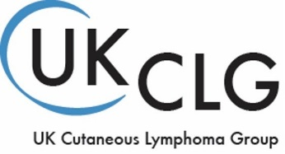

REGISTRATION FORM – UK Cutaneous Lymphoma Group Annual Meeting 2019
Thursday 2nd May 2019, Crowne Plaza Hotel, Liverpool
- Standard registration fee (consultants) £100
- Reduced registration fee (nurses and trainees) £75

Attendee 1 Details
First name
Surname
Job title
Work address
Work phone
Email address
Mobile phone
Dietary requirements

Attendee 2 Details
First name
Surname
Job title
Work address
Work phone
Email address
Mobile phone
Dietary requirements

Attendee 3 Details
First name
Surname
Job title
Work address
Work phone
Email address
Mobile phone
Dietary requirements

Attendee 4 Details
First name
Surname
Job title
Work address
Work phone
Email address
Mobile phone
Dietary requirements

CARD PAYMENT INFORMATION:
£
I give permission for you to deduct the sum of from the following payment card below for the registration/s listed above.

Card number:
Valid from date:
Expiry date:
3 digit security code:

INVOICE PAYMENT INFORMATION:

There is the option to raise an invoice if your trust will cover the cost of your registration fee, but this is on the strict understanding that payment will be made in advance of the course.

All invoices must be settled within 30 days of issue or before the event, whichever is soonest.

Invoice Contact Details
First name
Surname
Job title
Billing address
Work phone
Email address
Mobile phone

Please scan your form to conferences@lymphoma-action.org.uk or post it to
Lymphoma Action, 3 Cromwell Court, New Street, Aylesbury, Bucks HP20 2PB

If you have any questions please contact the Education and Training team on 01296 619412 or
conferences@lymphoma-action.org.uk before completing your booking.

