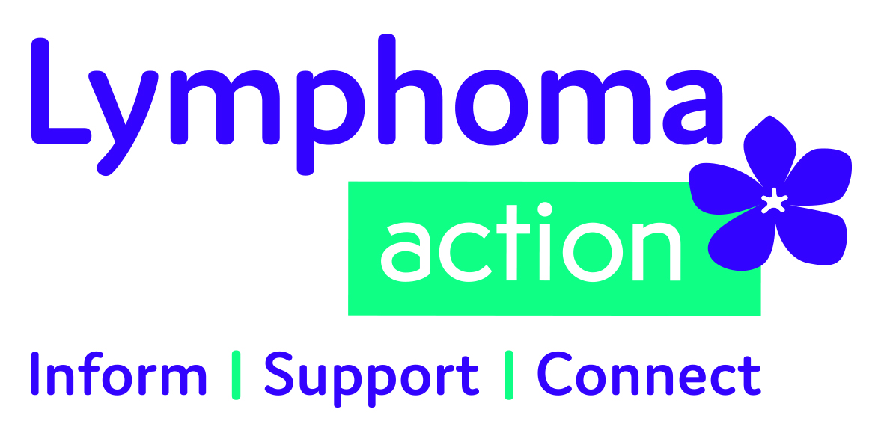

Equality and diversity monitoring form

Lymphoma Action wants to meet the aims and commitments set out in its equality policy. This includes not discriminating under the Equality Act 2010, and building an accurate picture of the make-up of the workforce in encouraging equality and diversity.
We need your help and co-operation to enable it to do this, however filling in this form is voluntary. The information you provide will stay confidential, and be stored securely and limited to only the staff our HR team.
Please return the completed form together with the employment application form.

Post applied for:

Gender Male  Female  Prefer not to say 

Are you married or in a civil partnership? Yes  No  Prefer not to say 

Age 16-24  25-29  30-34  35-39  40-44  45-49 
50-54  55-59  60-64  65+  Prefer not to say 

What is your ethnicity?
Ethnic origin is not about nationality, place of birth or citizenship. It is about the group to which you perceive you belong. Please tick the appropriate box

White
English  Welsh  Scottish  Northern Irish  Irish 
British  Gypsy or Irish Traveller  Prefer not to say 
Any other white background, please write in:

Mixed/multiple ethnic groups
White and Black Caribbean  White and Black African  White and Asian  Prefer not to say  Any other mixed background, please write in:

Asian/Asian British
Indian  Pakistani  Bangladeshi  Chinese  Prefer not to say 
Any other Asian background, please write in:

Black/ African/ Caribbean/ Black British
African  Caribbean  Prefer not to say 
Any other Black/African/Caribbean background, please write in:

Other ethnic group
Arab  Prefer not to say  Any other ethnic group, please write in:

Please see next page

Do you consider yourself to have a disability or health condition?

Yes  No  Prefer not to say 

What is the effect or impact of your disability or health condition on your ability to give your best at work? Please write in here:

The information in this form is for monitoring purposes only. If you believe you need a ‘reasonable adjustment’, then please discuss this with the manager running the recruitment process.
What is your sexual orientation?

Heterosexual  Gay woman/lesbian  Gay man  Bisexual 
Prefer not to say  If other, please write in:

What is your religion or belief?

No religion or belief  Buddhist  Christian  Hindu  Jewish 
Muslim  Sikh  Prefer not to say  If other religion or belief, please write in:

Please email this to jobs@lymphoma-action.org.uk with your employment application form.

Thank you for your time.

